TODO – counterfactuals

* scrivere che non ci sono differenze statostiche e spiegare procedimento, magari un grafico per spiegazione
* spiegare tabella ttest e inserire in appendix

Another method to assess the presence of discrimination and bias in our data and analysis is to employ a counterfactual analysis. In particular, we sample 1500 random observations from the test set without replacement to create an artificial test set. Each observation is then repeated twice more with a different minority status, so that in the end for each observation we have two counterfactual data points that have exactly the same characteristics except for their ethnicity.

We then use this new test set to obtain predictions and compare them across groups to find if the minority status plays a significant role in determining the *InterestRate*.

Specifically, **ttest**

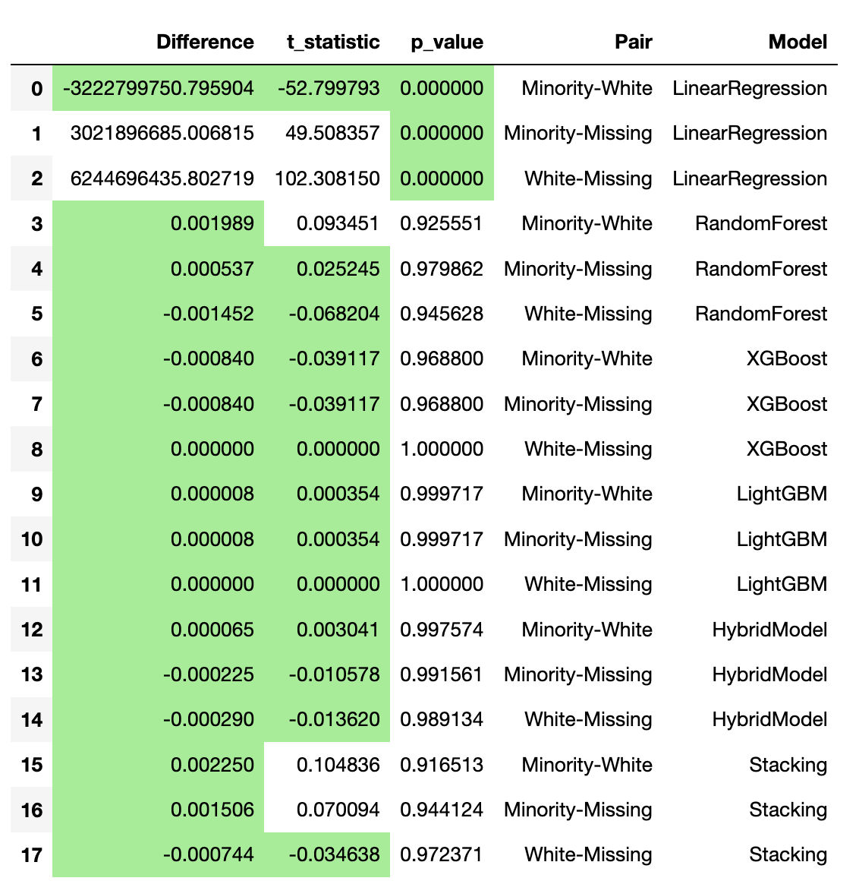

FARLO ANCHE PER GENDER ????? sì

Plot solo dei modelli non compositi (Forest, XGB, LGBM ) in appendix ?